Manuscript Template for IDS_STRUMO2016, Title in 10.5pt, Bold
Y B Yang¹, C M Wang² and J N Reddy³
1 Professor, School of Civil Engineering, Chongqing University, China
2 Professor, Dept. of Civil and Environmental Engineering, National University of Singapore, Singapore
3 Professor, Department of Mechanical Engineering, Texas A&M University, USA
ybyang@cqu.edu.cn, ceewcm@nus.edu.sg, jnreddya@tamu.edu

Abstract:
This is a template for abstracts to be presented at IDS_STRUMO 2016. It is our goal to be relatively flexible in format, yet maintain a reasonable degree of consistency among papers in the finished product. This document is formatted in the desired manner, and all authors are expected to use it as a template. Abstracts should be 300 words maximum.
Keywords: 3-6 keywords for indexing purposes (spaced by commas)

1 INTRODUCTION10.5pt, Bold
English will be the official language for papers to be included in the conference. All papers to be published in the Proceeding will be peer-reviewed by 2 reviewers selected from an international board of expert. The Academic Committee will inform the corresponding author of each provisionally accepted paper the comments by the board of reviewers. An electronic version of the final revised paper in WORD format should be sent to the conference secretariat at ids_strumo2016@163.com before the required deadline. Minor format modification and correction may be subsequently made by the editors themselves.
Use double column format for the whole test.
The maximum length of the whole draft manuscript beside keynote reports and invited papers is 6 pages including all figures, tables, etc. The font for text is Times New Roma, 9 pt. and the line space is 9.5 pt.
2 SECTION FORMAT
Leave 2 blank lines before the section headings and 1 blank line after them. The caption of each section heading is Arial, 10.5 pt.
The paper dimension and margins setting are described in Table 1.
Table 1. Paper dimension and margins(cm) (0.5 blank line before and after the caption of the table)
Paper dimension | Width | 16.9
Paper dimension | Height | 23.9
Margins | Top | 2.4
Margins | Bottom | 1.4
Margins | Left | 2.0
Margins | Right | 1.9
2.1 Secondary Headings or Sub-headings
Keep line spacing of 12 pt before the seconding headings and sub-headings and 6 pt after them. Leave one blank line between the section heading and the first line of the text.
Section headings are sequentially numbered and set in bold and full caps.
2.2 Citations
Citations in the text of the paper should use author last names and the year; for example, “… in previous work by the authors (Xiao et al., 2005; Ren and and De Roeck, 2002; Ru and Xiao, 2002)” or “… as shown in the work by Xu and Wu (2007) and Xiao and Anderson (2007).”
2.3 Tables and Figures
2.3.1 Tables
The table reference and heading should appear above the table as shown below. Use upper and lower letters for the title of the table.
Leave one blank line above the table heading and one blank line below the table (unless followed by a main section heading). SI units are preferred.
Table 2. The chemical components of clinker (%)
Loss | SiO₂ | Al₂O₃ | Fe₂O₃ | CaO | MgO | SO₃ | CaO | Amount
0.15 | 21.80 | 5.42 | 3.44 | 66.01 | 1.26 | 0.66 | 0.98 | 98.74

2.3.2 Figures

Illustrations are to be centred, with the reference and caption printed below the figure. All illustrations are to be referred to as figures and must be quoted in the text. For instance, see Figure 1 shows the schematic of set up of Four Point Bending Test.

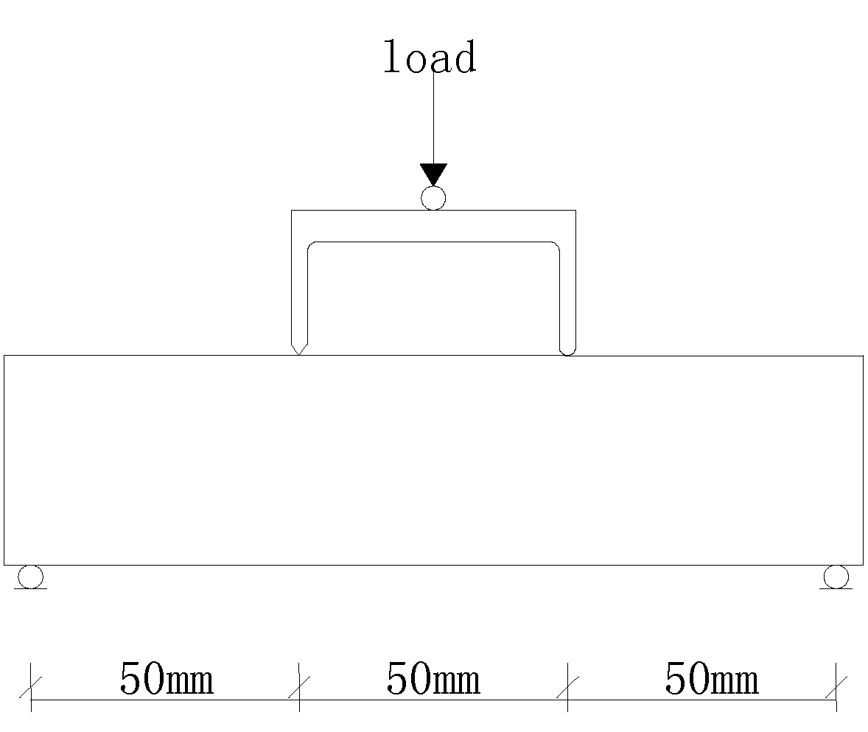

Figure 1. Schematic of set up of Four Point Bending Test (Keep 6 pt before and after the figure caption)
All illustrations are to be produced in black and white (or including shades of grey). If photographs are included, all photographs are to be scanned electronically and embedded within the text.
Leave one blank line above the illustrations and between the figure caption and the next paragraph (unless followed by a main section heading).

2.4 Equations

Equations should be inputted with Microsoft Equation Editor. Equations are to be centred, one blank line above and below, and the equation reference right justified. Equation references should be referred to in the text in the form Eq.1.

$F(x)=2y^{2}+a_{i}$ (1)

All symbols should be explained within the text of your manuscript.

Additionally, authors are responsible for obtaining permission for reprinting any material included in their papers that is already copyrighted elsewhere.

3 CONCLUSIONS
Conclusions should be included as a main section.
ACKNOWLEDGEMENTS
Acknowledgements, if any, are placed after conclusions.
REFERENCES
Author name/s. year. Paper Title. Journal title, Journal volume:issue, pages.
For cited books, the reference format is to be set as:
Author name/s. year. Book Title. Publisher.
For cited conference proceedings, the reference format is to be set as:
Author name/s. year. Paper Title. Proceeding title, Conference City, Country, Proceeding volume, pages.
Three reference examples are given below:
Ren W X, De Roeck G. 2002. Structural damage identification using modal data I: Simulation Verification. ASCE Journal of Structural Engineering, 128(1):87-95.
Ru J P, Xiao Y. 2002. Analysis of US NSF NEES program and critical evaluation of remote collaborations of structural testing in China. Journal of building structures, 91-94. (in Chinese)
Xiao Y, Anderson J C. 2007. Steel structure design. Beijing: Higher Education Press, China.
Xiao Y, He W H, Mao X Y. 2005. Research on confined concrete filled tubular (CCFT) columns. Proceedings of the Fourth International Conference on Advances in Steel Structures, Shanghai, China, 133-139.
Xu B, Wu Z. 2007. Decentralized and localized identifications of large-scale structures. Computer assisted mechanics and engineering sciences, 14(2):361-378.

