The 14th International Symposium on Structural Engineering (ISSE-14)
Oct.12-15, 2016
Beijing, China

Sponsored by
National Natural Science Foundation of China (NSFC)
Organized by
Beijing Jiaotong University
Co-organized by
Beijing University of Technology Collaborative Innovative Center of Engineering Disaster Prevention and Reduction in Liaoning
School of Civil Engineering, Beijing Jiaotong University Institute of Heritage Building Structures, Beijing Jiaotong University
Beijing’s Key Laboratory of Structural Wind Engineering and Urban Wind Environment Overseas Expertise Introduction Project for Innovation on Mitigating Wind-Induced Disaster of
Infrastructures Sensitive to Wind (111 plan)
Supported by
Journal of Building Structure

Guidance of the Kuntai hotel
昆泰酒店平面导引

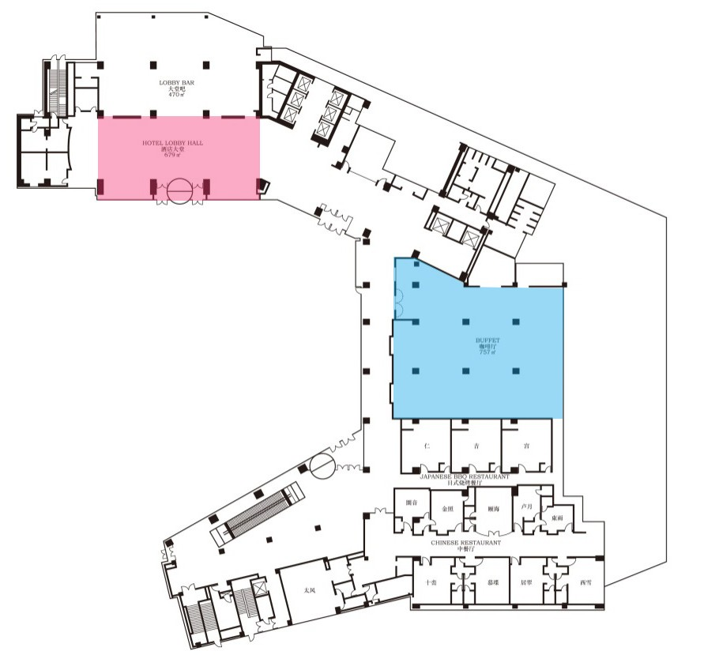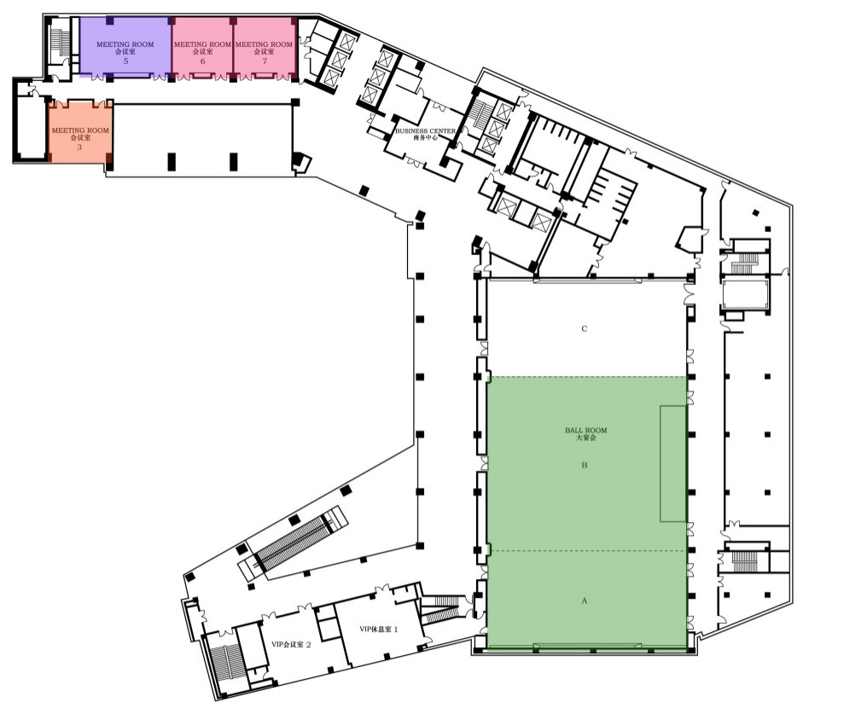
【一层 / Floor 1】
【二层 / Floor 2】

酒店大堂 /Lobby in Kuntai Hotel
自助餐厅 /Joy cafe
3 号会议室 /Meeting Room 3
- 号会议室 /Meeting Room 5
- 号会议室 /Meeting Room 6
宴会 A+B 厅 /Hall A+B

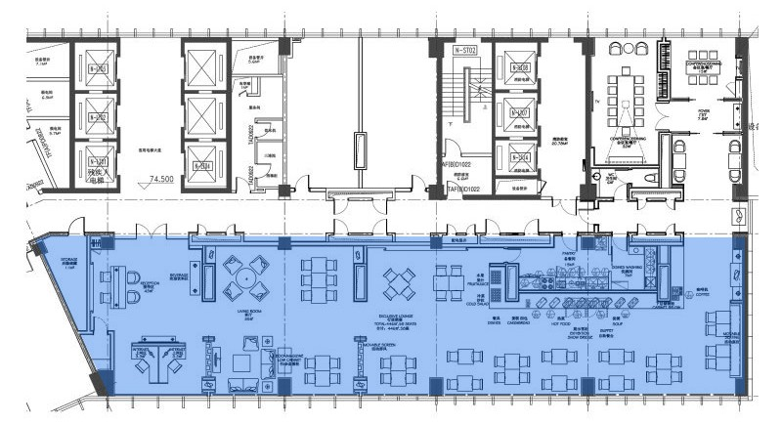
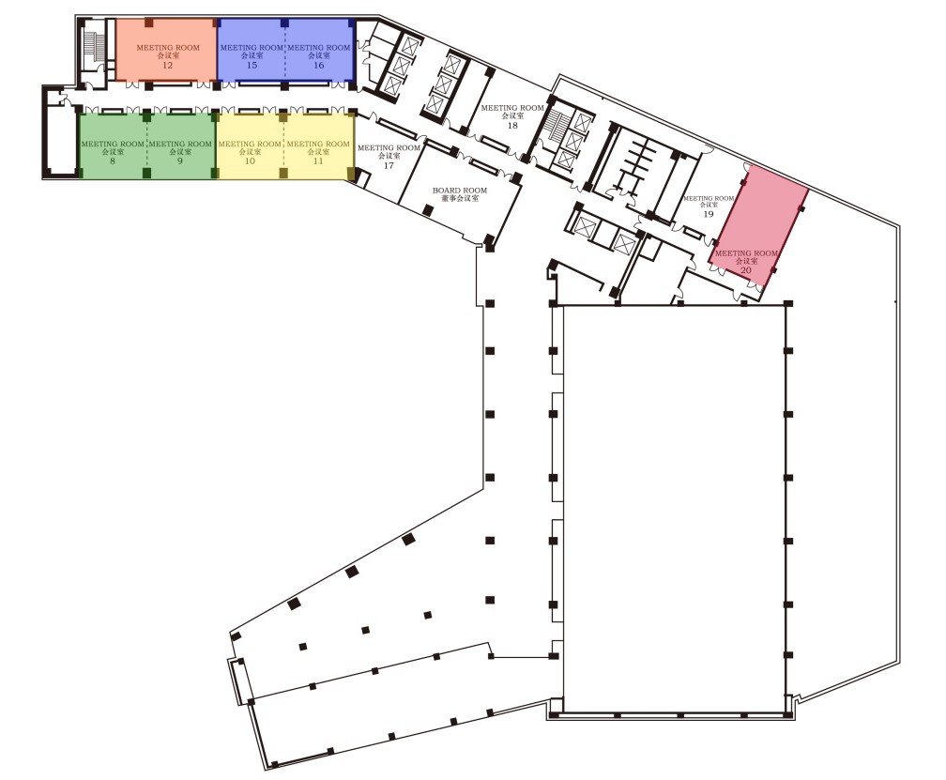【26 层 / Floor 26】
【三层 / Floor 3】

8 号会议室 /Meeting Room 8
10 号会议室 /Meeting Room 10
12 号会议室 /Meeting Room 12
15 号会议室 /Meeting Room 15
20 号会议室 /Meeting Room 20

行政酒廊 /Executive Lounge

Notices for the symposium
会议期间注意事项

【住宿】请所有代表尽量于 10 月 12 日 10:00~21:00 或 13 日早 7:30 前到昆泰酒店 ( 北京市朝阳区望京启阳路 2 号，酒店前台电话：010-
84106118) 一层大厅报到，已经通过会务组预定昆泰酒店房间的代表需凭报到条去前台办理入住，否则无法入住。退房时间为退房当日的
下午 14:00 前，请各位代表合理安排自己的行程。
【Accommodation】 Please register on the Kuntai hotel lobby on Oct. 12 or before 7:30 a.m. on Oct. 13. The latest checking out time is 14:00 pm. The Kuntai hotel locates on No.2, Qiyang Road, Chaoyang District, Beijing. Its phone number is +8610-84106118.

【代表证和餐券】代表证是入会场的唯一凭证，务请随身佩带，内有餐券，凭券就餐，遗失不补，请妥善保管。提示：由于参会人数较多， 就餐时段集中，自助餐可能会出现排队现象，由此给您造成的不便我们深表歉意，希望您能理解！
【Representative card and meal ticket】The representative card bag contains a representative card and the meal tickets. Please take the representative card with you for entering the meeting room and dining hall.Because of the large number of participants, there may have a long queue for the buffet during dining period, we are sorry for the trouble and hope you can understand!

【发票】已汇款预注册代表，请在 13、14 日 10:00-16:00 到酒店一层会务组处领取发票；现场缴费代表，缴费时开具收据，14 日 14:00- 18:00、15 日 9:00-12:00 到酒店一层会务组处凭收据领取发票。开具收据时请务必提供准确的发票信息和联系电话 , 需要增值税专用发票 的请提前备好相关信息。另外，为了方便沟通交流，建议带上本人名片。
【Invoice】 Pre-registered delegates can receive the invoices with the bank receipt from the registration desk on the hotel lobby from 10:00-16:00 on Oct.13 and 14. For those delegates who register onsite will receive a receipt first, and substitute the invoice at the registration desk on the hotel lobby from 9:00-12:00 on Oct. 15. Please provide the title of the invoice and contact information when you pay on site. For your convenience, it is kindly suggested to bring the name card.

【关于会议资料】会议资料袋内包括：摘要集、U 盘（内有论文集电子版）、会议手册（后附可用于笔记的空白页）、《建筑结构》杂志、 宣传单、代表证（内含餐券）、笔。
【The Conference Material includes】 Proceedings of abstracts, USB, conference handbook, Journal of Building Structure, leaflets, representative
card bag (contains representative card and meal tickets), pen.
■ 正式出版会议论文集（纸质）领取说明
U 盘中的电子论文集包含了所有会议论文；正式出版论文集仅包含送 ISTP 检索的论文。每篇要求送 ISTP 检索的论文可以赠送一套正式出 版论文集，参会的论文作者可于 10 月 13 日 10:00-16:00 到酒店一层会务组处领取。会务组联系人：钟凯 15810180278
The USB contains all the ISSE-14 papers. The special issue only publishes the papers requiring ISTP. Only the ISTP paper can have a special issue, please get it from registration desk on the hotel lobby from 10:00-16:00 on Oct. 13. Contact:Kai ZHONG +86 15810180278
1
■ 因涉及版权问题，除非报告专家和学者主动授权，组委会不提供报告专家和学者 PPT 文件。若需要相关资料，请与会代表自行联系报告 人。报告专家和学者主动授权的资料将会通过《建筑结构》官方微信发布（微信号：BuildingStructure）。
Due to the copyright protection, the conference slides, video material and contact information of delegates will not be distributed. If you need any material, please contact the reporter. The slides that reporter agrees to share will be put on the formal WeChat of Journal of Building Structure (WeChat account: BuildingStructure), please notice.
■ 会议通讯录与会议合影将在会议结束后通过电子邮件发给与会代表和论文作者。
Conference address book and the photo will be delivered to all the participants through email.

【参会代表外出时注意安全，如需帮助请及时与会务组联系】

【Please pay attention to your safety when you go out. If you have any problem, please contact meeting staffs】

Location for the conference and accommodation
会议及住宿地点

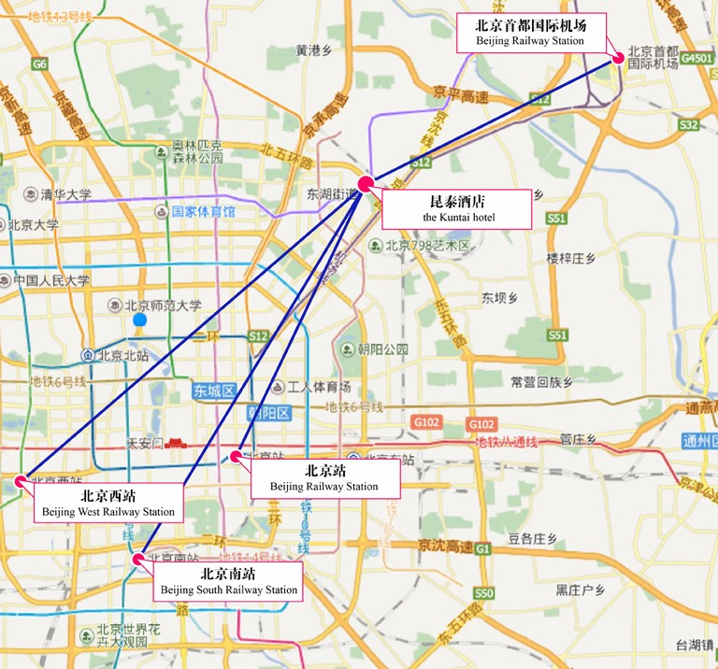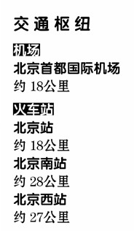昆泰酒店 ( 北京市朝阳区望京启阳路 2 号 )。住宿费：600 元 / 间 / 天（含早餐）。 在会议现场报到完成后，请将住宿费直接交付宾馆，费用自理。
Kuntai hotel (No.2, Qiyang Road, Chaoyang District, Beijing). Living fee: 600 RMB / d for each room (breakfast included). The living fee will be paid by yourself when you check in.

【建筑结构微信】

Contact information of conference staff
会务组联系方式

李 娜：15801601545（会议报到），李会珍：18618268712（会议报到） 李青青：18911880577（会议住宿），吴 琼：13810273081（会议发票） 钟 凯：15810180278（会议论文集领取），褚浩玥：15810161056（参观） 杨 琳：18701529806（会议咨询），杨 娜：13641094920（会议咨询） 注：论文宣读事宜请联系各会场秘书，联系方式详见后面日程安排
Na LI：+86 15801601545 (Responsible of conference registration) Huizhen LI：+86 18618268712 (Responsible of conference registration) Lin YANG：+86 18701529806（Conference consultation）
Na YANG：+86 13641094920（Conference consultation）

Introduction

The 14th International Symposium on Structural Engineering (ISSE-14) will be held in Beijing, China. The ISSE-14, scheduled on Oct. 12-15, 2016, is sponsored by the National Natural Science Foundation of China (NSFC). It will be organized by Beijing Jiaotong University, and is co-organized by Beijing University of Technology. The Symposium was derived from the International Symposium on Structural Engineering for Young Experts (ISSEYE) which was held in Leshan, China since 1990. It has been held biannually in China since in Harbin (1992), Shanghai (1994), Beijing (1996), Shenyang (1998), Kunming (2000), Tianjin (2002), Xi’an (2004), Fuzhou (2006), and Changsha (2008). When it was held in Guangzhou in 2010, the title of the symposium was updated to “The International Symposium on Structural Engineering (ISSE)”, and it was also held in Wuhan (2012) and Hefei (2014) with this title. Till now, it has been successfully held for 13 times. With more than 20 years’ of development, ISSE has become attractive to many young and middle-aged elite Chinese scholars all over the world with its distinct characteristics and features. The objective of ISSE-14 is again to provide a forum for experts from the research and engineering communities, who work worldwide in the broad areas of structural engineering and construction, to present recent progress in research and development; to exchange information on the topics of structural analysis, design, construction, maintenance and hazard mitigation; and to discuss the implementation and development of new tools and technologies for professional application leading to safe and sustainable infrastructure. ISSE also aims to promote close international collaboration, cooperation, and mutual understanding.

Advisory Committee

Chairman
Shizhao SHEN, Harbin Institute of Technology, China

Vice Chairman
Fulin ZHOU, Guangzhou University, China
Yukio TAMURA, Beijing Jiaotong University, China

Members (In alphabetical order)
Ahsan KAREEM, University of Notre Dame, USA Giovanni SOLARI, University of Genoa, Italy Zhengqing CHEN, Hunan University, China Yanliang DU, Shijiazhuang Tiedao University, China Changwen MIAO, Southeast University, China Jianguo NIE, Tsinghua University, China
2
Jinping OU, Dalian University of Technology, China Shunquan QIN, Southwest Jiaotong University, China
Xuwen XIAO, State Construction Engineering Corporation, China Yeong-Bin YANG, Chongqing University/Taiwan University, China Xuhong ZHOU, Chongqing University, China

Academic Committee

Chairman
Qingshan YANG, Beijing Jiaotong University, China

Members (In alphabetical order) Kaiming BI, Curtin University, Australia
Chunsheng CAI, Louisiana State University, USA Jianfei CHEN, Queen’s University Belfast, UK
Nawawi CHOUW, the University of Auckland, New Zealand Jie CUI, Guangzhou University, China
Yang DING, Tianjin University, China
Xiuli DU, Beijing University of Technology, China
Qin FANG, PLA University of Science and Technology, China Hanbin GE, Meijo University, Japan
Yaojun GE, Tongji University, China Linhai HAN, Tsinghua University, China
Hong HAO, Curtin University, Australia/Tianjin University, China

Bin HUANG, Wuhan University of Technology, China Zongming HUANG, Chongqing University, China Weiliang JIN, Zhejiang University, China
Ying LEI, Xiamen University, China
Hui LI, Harbin Institute of Technology, China Jie LI, Tongji University, China
Aiqun LI, Southeast University, China
Dapeng LI, National Natural Science Foundation of China, China Dawang LI, Shenzhen University, China
Hongnan LI, Dalian University of Technology, China
Qingming LI, the University of Manchester, UK/Beijing Institute of Technology, China Qiusheng LI, City University of Hong Kong, China
Xiaojun LI, Institute of Geophysics, China Earthquake Administration/ Beijing University of Technology, China Zhongxian LI, Tianjin University, China/Tianjin Chengjian University, China
Weiqing LIU, Nanjing University of Technology, China Wenguang LIU, Shanghai University, China
Guoxing LU, Swinburne University of Technology, Australia/Tianjin Chengjian University, China Yong LU, the University of Edinburgh, UK
Guowei MA, the University of Western Australia, Australia/Beijing University of Technology, China
Z. John MA, the University of Tennessee Knoxville, USA
Ditao NIU, Xi’an University of Architecture and Technology, China Weixin REN, Hefei University of Technology, China
Jiping RU, National Natural Science Foundation of China, China Gangbing SONG, University of Houston, USA
Zhong TAO, University of Western Sydney, Australia
Jun TENG, Harbin Institute of Technology, China

3
Jinguang TENG, the Hong Kong Polytechnic University, China
Xintang WANG, Ningbo University, China
Bo WU, South China University of Technology, China Zhishen WU, Ibaraki University, Japan
Chenqing WU, the University of Adelaide, Australia/Tianjin Chengjian University, China Yan XIAO, University of Southern California, USA/Hunan University, China
Feng XING, Shenzhen University, China Bin XU, Hunan University, China
Yong XIA, the Hong Kong Polytechnic University, China Youlin XU, the Hong Kong Polytechnic University, China Zhiwu YU, Central South University, China
Yunfeng ZHANG, University of Maryland, USA Yangang ZHAO, Kanagawa University, Japan Xiaolin ZHAO, Monash University, Australia Yun ZHOU, Guangzhou University, China
Hongping ZHU, Huazhong University of Science and Technology, China
Xinqun ZHU, University of Western Sydney, Australia/Tianjin Chengjian University, China

Local Organizing Committee

Chairman
Na YANG, Beijing Jiaotong University, China

Members (In alphabetical order)
Bo Chen, Zhibao Cheng, Bo Li, Mingqi Lu, Yuji Tian, Xiaofeng Wang, Juan Wang, Di Wu, Jihui Xing, Longhe Xu, Hongjun Xiang, Jian Zhang, Changdong Zhou (Beijing Jiaotong University, China)
Qiang Han, Liu Jin, Guojun Sun, Chengshun Xu, Lu Yang, Mi Zhao (Beijing University of Technology, China)

Overview
4
Wednesday Oct 12, 2016
10:00-21:00 | Registration | Lobby in Kuntai Hotel
18:00-20:30 | Dinner (buffet) | Dining Hall, 1st Floor
Thursday Oct 13, 2016
8:10-8:40 | Opening Ceremony | Hall A+B, 2nd Floor
8:40-12:00 | Keynote presentations:  Fulin Zhou, Yukio Tamura, Mehdi Saiid Saiidi, Xilin Lü, Kazuhiko Kasai | Hall A+B, 2nd Floor
12:00-14:00 | Lunch (buffet) | Dining Hall, 1st Floor /  Executive Lounge, 26thFloor
14:00-18:30 | Invited presentations and Session presentations | Meeting Room 3, 5, 6, 2nd Floor  Meeting Room 8, 10, 12, 15, 20, 3rd Floor
19:00-20:30 | Banquet | Hall A+B, 2nd Floor
Friday Oct 14, 2016
8:10-12:00 | Keynote presentations:  Jiping Ru , Jie Li, Jinping Ou, Xiuli Du, Hongnan Li, Yaojun Ge, Junhai Yong, Qingrui Yue | Hall A+B, 2nd Floor
12:00-14:00 | Lunch (buffet) | Dining Hall, 1st Floor /  Executive Lounge, 26thFloor
14:00-18:30 | Invited presentations and Session presentations | Meeting Room 3, 5, 6, 2nd Floor  Meeting Room 8, 10, 12, 15, 20, 3rd Floor
19:00-20:30 | Dinner (buffet) | Dining Hall, 1st Floor
20:30-22:00 | Meeting of Academic Committee | Meeting Room 5, 2nd Floor
Saturday Oct 15, 2016
8:10-11:30 | Keynote presentations:  Xuhong Zhou, Ahsan Kareem, Zhengqing Chen, Ian Buckle, Yeong-Bin Yang, Billie F. Spencer Jr. | Hall A+B, 2nd Floor
11:30-12:00 | Closing Ceremony | Hall A+B, 2nd Floor
12:00-14:00 | Lunch (buffet) | Dining Hall, 1st Floor
14:00- | Leaving

Opening and Keynotes
Hall A+B, 2nd Floor

5
Thursday Oct 13, 2016
Opening Ceremony
8:10-8:40 | Opening Ceremony Chair: Na YANG
Keynote presentations
Chairs: Prof. Jinping Ou and Prof. Giovanni Solari
Secretary: Xiaoda XU / 18210621559
8:40-9:10 | Fulin ZHOU | Development and application on seismic isolation, energy dissipation and structural control in China
9:10-9:40 | Yukio TAMURA | Relation between design load level and lifetime of individual building and its elements
9:40-9:55 | Ahsan Kareem | Awarding Davenport Medal and Certificate to Prof. Yukio Tamura
9:55-10:10 | Group picture taking; Square, in front of the Hotel
10:10-10:30 | Coffee break
Keynote presentations
Chairs: Prof. Ian Buckle and Prof. Hongnan Li
Secretary: Xiaoda XU / 18210621559
10:30-11:00 | Mehdi Saiid SAIIDI | New horizons in seismic design of highway bridges with advanced materials and construction methods
11:00-11:30 | Xilin LÜ | Shaking table test and numerical simulation of self-centering RC frames
11:30-12:00 | Kazuhiko KASAI | Current status of motion control to mitigate seismic damage of high-rise buildings and contents
12:00-14:00 | Lunch (buffet) | Dining Hall, 1st Floor / Executive Lounge, 26thFloor

Invited Presentations & Session Presentations
6
Thursday Oct 13 | Session 1  Meeting Room 8, 3rd Floor Wind Climate & Wind Effects Chairs:  Kenny Kwok and Bo Chen Secretary:  Ying ZHU / 15810899396 | Session 2  Meeting Room 10, 3rd Floor Wind Load on Roofs & Solar Panels  Chairs:  Qiusheng Li and Shuyang Cao Secretary:  Yuan XUE / 17801021158 | Session 3  Meeting Room 12, 3rd Floor Dynamic Vibration & Control Chairs:  Yong Xia and Jenmu Wang Secretary:  Zhangting YAO / 18813071407 | Session 4  Meeting Room 15, 3rd Floor Novel Structural System, Composite and Hybrid Structures  Chairs:  Ditao Niu and Qiuhong Zhao Secretary:  Chunyu XIA / 15210577620
14:00-14:20 | 21* (invited)  Advances in properties  of thunderstorm outflows relevant to the wind loading of structures  Giovanni Solari | 20* (invited)  Wind pressures on solar panels: current state-of-the-art  Ted Stathopoulos | 35* (invited)  Towards predicting the acceleration of a standing human whole-body in vertical structural vibration  Tianjian Ji | 37* (invited)  Smart rehabilitation of composite structures using innovative bolted shear connectors  Xinqun Zhu
14:20-14:40 | 24 (invited)  New frontiers in wind engineering  Horia Hangan | 22 (invited)  Integration of wind tunnel pressure measurements with the structural model for a large roof  Richard G.J. Flay | 212  Analysis of damped outriggers system  Ping Tan, Chuangjie Fang, and Fulin Zhou | 248  Static and fatigue behaviors of stud shear connectors in elastic concrete-steel composite beam Jie Xu, Guang Yang, and Qinghua Han
14:40-14:55 | 121  The distribution of the maximum response of structures to synoptic wind actions  Giuseppe Piccardo, Serena Poggi and Giovanni Solari | 120  A super lightweight hurricane- resistant thin-walled box-cell roofing system  Ehssan Amir Sayyafi, Amir Mirmiran, Arindam Gan Chowdhury | 197  Numerical simulation of dynamic behaviors of large- scale magnetorheological fluid dampers  Y.B. Peng, J.G. Yang | 230  Loading method for composite columns with arbitrary bending moment to torsion moment ratio  Yuhang Wang, Jianguo Nie, and Jiansheng Fan
14:55-15:10 | 128  Evaluation of interpolation- enhanced schemes in the unconditional simulation of wind field  Hao Wang, Tianyou Tao | 174  Vunerability evaluation of roof panels with consideration of wind pressure correlation Guoqing Huang, Xiaowen Ji, Ying Luo, Kurtis R. Gurley | 199  An elastic-plastic time-history analysis on tructure with MR damper  Yuliang Zhao, Zhaodong Xu, Xiangcheng Zhang | 242  Experimental study of ultra- large capacity end-plate connections under axial load Xuesen Chen, Gang Shi, and Dongyang Wang
15:10-15:25 | 173  Spectral method for fatigue damage assessment  Ying Zhu, Yuji Tian | 153  Non-stationary statistics of non-Gaussian wind pressure processes on a large-span long roof  M.F. Huang, He Feng, Song Huang and Wenjuan Lou | 200  Performance of base-isolated adjacent structures with  an integrated base plate in preventing pounding under earthquake  Kai Chen, Zhiwei Miao, Aiqun Li, Yong Lu | 239  Experimental investigation on Hysteretic behaviour of sqaure hollow section brace-H-shaped chord T-joints  Fei Gao, Gengmu Ruan, Xianyuan Zhao and Xinze Guo
15:25-15:40 | 157  Wind characteristics near flat ground at and inside the periphery of strong typhoons during the landfall process Jingjing Pan, Lin Zhao , Xudong Liang, Lili Song, Ledong Zhu and Yaojun Ge | 172  Wind pressures on low-rise buildings with complex roofs: basic aerodynamics and local wind loads  Shuai Shao, Ted Stathopoulos, Qingshan Yang and Yuji Tian | 201  Prilimitary study of tmd control of structures with shear- bending coupling  Yumei Wang, and Zhe Qu | 223  Fire resistance of concrete- filled circular steel tubular columns with internal profiled steel under axial compression Wenjing Mao, Yanli Shi, Wenda Wang
15:40-15:55 | 143  Research on homogeneous turbulence simulation in boundary layer wind tunnel based on oscillating-grid Kun Lin, Hongjun Liu, Fenyang Wei, Qin Huang | 130  Characteristics of wind-induced vertical vibrations of solar wing structure  Yong Chul Kim, Yukio Tamura, Akihito Yoshida, Takashi Itoh, Shan Wenshan, Qingshan Yang | 202  Experimental tests on active control for a twelve-story seismic model structure Weijing Zhang, and Xiaofei Liu | 241  Comparison of design methods for the panel zone in different design codes  Tanshu Xiao, Gang Shi
15:55-16:10 | 129  Modeling and application of the WRF-based engineering wind model for tropical cyclone  Xue Lin, Li Ying | 150  Collapse process of pipe- framed greenhouses under static wind loading Kazuya Takahashi,Yuki  Takadate and Yasushi Uematsu | 203  Multiscale simulation of isolated structure considering rubber bearing details  Hui Wang, Wanrun Li, YuPing Sun, Yongfeng Du, Xueping Wang | 161  Inter- and intra-structure couplings of wind-excited linked tall buildings  Jie Song, Shuguo Liang and  K.T. Tse
16:10-16:30 | Coffee break

*order number in the abstract proceedings

7
Thursday Oct 13 | Session 5  Meeting Room 20, 3rd Floor  Bridge Structures Chairs:  Zhiwu Yu and Suiwen Wu Secretary:  Zhengyuan HUANG / 18811126609 | Session 6  Meeting Room 6, 2nd Floor Earthquake Engineering and Aseismic Design  Chairs:  Kaiming Bi and Tony T.Y. Yang Secretary:  Junxiao HE / 18813093455 | Session 7  Meeting Room 5, 2nd Floor Structural Health Monitor Damage Detection  Chairs:  Weixin Ren and Hongjun Xiang Secretary:  Lei LIU / 13811633951 | Session 8  Meeting Room 3, 2nd Floor Structural Rehabilitation, Retrofitting and Strengthening Chairs:  Ying Lei and Changdong Zhou Secretary:  Danyang DAI / 13810202534
14:00-14:20 | 55* (invited)  Bridge condition assessment based on vehicle and bridge interaction  C.S. Cai | 34* (invited)  Simulation of the in-plane and out-of-plane seismic performance of nonstructural partition walls with returns  E. Manos Maragakis | 33* (invited)  Cloud-based cyber infrastructure for bridge monitoring  Kincho H. Law | 39* (invited)  The state of the art of concrete structure durability monitoring and restoration  Weiliang Jin
14:20-14:35 | 267  Full-scale ambient vibration test and finite element calibration of a concrete-filled steel tubular arch bridge  Yun Zhou, Junkai Zhang, Hanyu Peng, Weijian Yi | 90  Seismic reliability of reinforced concrete structures with random-field parameters Jingran He, Jianbing Chen | 175  Equivalent identification of joint dynamic parameters based on particle swarm optimization algorithm  Wenfeng Luo and Ling Yu | 257  Seismic damages of Nepalese cultural heritage buildings and strengthening measures -- case studies on three durbar squares in MS8.1 Gorkha earthquake Pan Yi,Yuan Shuang,Xie Dan,Wang Xiaoyue
14:35-14:50 | 268  Pier scour assessment by dynamic performances of structures  Wen Xiong, Jianshu Ye, C.S. Cai | 94  Seismic performance of fish- bone BRBS with different configurations  Liangjiu Jia, Hanbin Ge, and Yan Liu | 179  A novel structural damage detection method using wireless sensor networks  Chengyin Liu, Xishuang Han | 105  Vertical earthquake research on seismic response of pedestrain bridges  Wenxue Zhang, Zhen Wang, Hailu Liu and Rong Fang
14:50-15:05 | 269  Effects of track structure on the concrete bridge–borne noise subjected to train impacts  Xun Zhang, Dewang Yang, Jianqiang Zhang, and Xiaozhen Li | 95  Seismic response of buried pipeline in heterogeneous stratum field  Liyun Li, Xiaoxiao Liu, Xiao Zuo, Junyan Han,and Xiuli Du | 182  Field measurement on vibration reduction effects of anti- vibration bearings for vertical train-induced vibrations Liangming Sun, Weiping Xie, and Wei He | 308  Compressive behavior of damaged concrete confined with FRP composites and crack process monitoring  Gao Ma, Hui Li
15:05-15:20 | 271  Number of stress cycles for fatigue design of simply- supported steel I-girder bridges Wei Wang, Lu Deng | 96  Seismic behavior and design of replaceable steel coupling beam  Xiaodong Ji, Yandong Wang and Junshan Zhang | 176  Regularization parameter selection scheme for moving force identification  Huanlin Liu and Ling Yu | 309  Research on key controlling factors for deformation & crack of GFRP reinforced concrete beams under serviceability limit state  Can Sun, Yu Zheng, and Xin Zhang
15:20-15:35 | 273  Extremely low-cycle fatigue crack initiation life prediction of thick-walled steel bridge piers  Shengbin Gao, Shiliang Chi, Hanbin Ge | 213  Shaking table test of vibration control effects of particle tuned mass damper  Zheng Lu, Xiaoyi Chen, Jiang Du, Xinlin Lu | 178  Experimental study about the influence of sensor arrangement for long lining structural damage identification Shengnan Wang, Hui Luo, Hongping Zhu, and Wen Fu | 311  The behaviour of concrete bridge deck slabs strengthened with NSM FRP bars under the concentrated loads  Yu Zheng , Lipeng Xia and Can Sun
15:35-15:50 | 292  Ductile crack initiation evaluation in steel bridge piers subjected to random cyclic loading  Lan Kang and Hanbin Ge | 91  Seismic behavior of concrete- encased CFST industrial workshop structures  Guolei Xing, Jinyang Chen, Yongfeng Wang, Chao Hou, Ye Cui, Danyang Ma | 183  A statistical model updating method of beam structure using static measurement data with non-Gaussian errors  Zhifeng Wu and Bin Huang | 310  Symptom-based reliability analysis and remaining service life prediction for steel bridge members due to fatigue  Tianli Huang, Yanjie He, Huapeng Chen
15:50-16:05 | 280  Computational analysis of wave force of substructure to cross-sea bridge based on code and numerical simulation Chen Fang, Yongle Li,  Zilong Ti, Dapeng Mei, Shunquan Qin | 170  Calculation of structural responses and response sensitivities by dynamic condensation approach Shun Weng, Wei Tian, Hongping Zhu, Yong Xia, Fei Gao, Funian Li | 184  A study of projection scheme based on orthogonalizable power polynomial basis vector Yejun Li, Bin Huang, Jun Liu, Heng Zhang | 305  Impact resistance of flax fibre reinforced polymer laminates coconut fibre reinforced concrete (FFRP-CFRC) beams Wenjie Wang and Nawawi Chouw
16:05-16:30 | Coffee break

*order number in the abstract proceedings

8
Thursday Oct 13 | Session 9  Meeting Room 8, 3rd Floor Wind Effects on High-rise Buildings  Chairs:  Giovanni Solari and M.F. Huang  Secretary:  Ying ZHU / 15810899396 | Session 10  Meeting Room 10, 3rd Floor Wind Tunnel Tests & Field Measurments  Chairs:  Richard G.J. Flay and Guoqing Huang  Secretary:  Yuan XUE / 17801021158 | Session 11  Meeting Room 12, 3rd Floor Dynamic Vibration & Control Chairs:  Tianjian Ji and Pin Tan Secretary:  Zhangting YAO / 18813071407 | Session 12  Meeting Room 15, 3rd Floor Novel Structural System, Composite and Hybrid Structures  Chairs:  Xinqun Zhu and Qinghua Han Secretary:  Chunyu XIA / 15210577620
16:30-16:50 | 28 (invited)  An acrosswind equivalent static wind load model for rectangular shaped tall buildings  Chii-Ming Cheng | 29 (invited)  Field measurements of typhoon-induced wind effects on low-rise buildings Qiusheng Li | 30 (invited)  Typhoon-induced and temperature-induced responses of a supertall structure  Yong Xia | 51 (invited)  Study on the durability of concrete with environmental corrosion and fatigue load Ditao Niu
16:50-17:10 | 26 (invited)  Motion perception, occupant comfort and work performance in wind-excited tall buildings Kenny Kwok | 25 (invited)  A new interplitation of galloping of a rectangular cylinder in smooth flow Hiromasa Kawai | 165  The establishment of wind spectrum estimation models for dome-like structures using artificial neural networks Jenmu Wang, Yuan-Lung Lo, Po-Yi Liu, Yuh-Yi Lin and Cheng-Hsin Chang | Parametric studies on the ductility performance of integral abutment bridges Qiuhong Zhao
17:10-17:25 | 164  Downstream interference effect of high-rise buildings under turbulent boundary layer flow Yuan-Lung Lo, Yong Chul Kim, and Yi-Chao Li | 126  Tornado-induced wind pressures on a cooling tower Shuyang Cao, Jin Wang, and Jinxin Cao | 149  The introduction of the system of monitoring and early- warning of gale in driving control  Chuanjin Yu, Yongle Li | Seismic performance of corrugated steel plate shear walls (CoSPSWs) and stiffened steel plate shear walls  Qiuhong Zhao
17:25-17:40 | Wind effects of one cable- suspended roof with full-scale measurement and wind tunnel based method  Bo Chen | 122  Large eddy simulation of turbulent atmospheric boundary layer through recycling rescaling revising method Chao Li, Jinghan Wang and Yiqing Xiao | 167  Principles of taking values of wind-induced interference factors for a group of large- scale cooling towers  Jinxin Cao, Yezhan Li, Lin Zhao, and Yaojun Ge | 246  Study on bearing capacity of composite shear wall with CFST columns incorporating FRP-confined concrete core Fengming Ren, Yaxin Guo, Zhaopeng Liu, Jinwen Chen
17:40-17:55 | 119  Multivariate analysis on Reynolds number effects of wind loads on rectangular high- rise buildings based on wind tunnel tests  Yao Zou, Shuliang Wang, Shuguo Liang and Lianghao Zou | 135  Numerical study on wind turbine wakes: parameters analysis  Jianxiao Hu, Qingshan Yang, and Jian Zhang | 162  Wind load model for large-span flat roofs and its application in database-assisted design  Ning Su, Ying Sun, Yue Wu and Shizhao Shen | 93  Experimental study on buried pipe network using an artificial earthquake  Huiquan Miao, Wei Liu, Chuang Wang and Jie Li
17:55-18:10 | 146  Dynamic response and fatigue analysis of semi-submersible offshore platform with upper high-rise tower under combined wind & wave loads  Jin Ma, Dai Zhou, Fangfei Li | 137  LES simulation of unsteady aerodynamic characteristics for large-span flat roof Tian  Li , Qingshan Yang , Takeshi Ishihara and Jian Zhang | 160  Study on coastal bridge damage under the action of extreme wave  Bo Huang, Bing Zhu, Jiawei Zhang | 195  Robust design of a new composite tuned liquid damper Jingyao Zhang and Kenny Kwok
18:10-18:25 | 125  Comparative study of along- wind and across-wind loads on tall buildings with different codes  Zhengwei Zhang, Alex To | 134  Wake flow induced vibrations  of vertical hangers behind the tower of a long-span suspension bridge  Wenli Chen, Donglai Gao, Hui Li and Hui Hu | 214  Large attenuation zones and vibration responses in periodic slabs with cross-like holes Jiankun Huang, Xiaohan Wan, Wen Liu, Ke He, and Hongtao Liu | 206  Numerical analysis of progressive collapse of vertically irregular RC isolated frame steucture due to sudden failure of isolator  Yongfeng Du, Xiaoning Huang, Chao Bao

18:25-18:50 | 142  Experimental investigation of the characteristics of unsteady wind loads on high- rise building with rectangular section  Jiadong Zeng and Mingshui Li | 226  Experimental study on a new type of composite beam with corrugated steel webs Chaoran Guo, Muxuan Tao, Jianguo Nie, Liang Dai, Xianqian Wang and C.S.Cai | 224  Experimental study• on the compression of variable concrete filled steel tubular laced columns  Jun Zhou, Jiangang Wei, Lei Huang, Baochun Chen | 238  Research on the behavior of CTLC stub columns under axial compression  Bin Li, Miao Li, Chunyan Gao
 | 147  Numerical study of flow around circular cylinders with shape modification  Kai Zhang, Dai Zhou, Hiroshi Katsuchi and Hitoshi Yamada | 225  Experimental research on concrete-encased composite columns with l-shaped steel sections  Yunfeng Xiao , Zhengtao Zhou  , Yiguang Chen, Siqian Jin, and Lei Zeng | 72  Analysis on optimal variable cross-sectional cantilever Jiansuo Ma, Miaomiao Zhou,Huanqin Cai, Runshan Bai and Shuan Feng | 240  Static and fatigue behaviors of stud shear connectors in elastic concrete-steel composite beam Jie Xu, Guang Yang, and Qinghua Han
 | 209  Damage performance evaluation of eccentric isolated structure system considering impact under ground motions Qiaorong Yang, Maolai Ran, Tianjiao Ren, Yang Liu | 198  Discrete element method numerical investigation on the particle damper  Shaozhen Duan, Wenda Wang | 227  Experimental and numerical investigation on steel-concrete composite beam with uplift- restricted and slip-permitted screw-type connectors  Sanwei Han, Muxuan Tao, Jianguo Nie, and C.S. Cai | 228  Study of mechanical properties of a type of lightweight composite slab under static loads  Jing Yang, Haisong Gu, Xintang Wang
19:00-20:30 | Banquet |  | Hall A+B, 2nd Floor

9

10
Thursday Oct 13 | Session 13  Meeting Room 20, 3rd Floor  Bridge Structures Chairs:  C.S. Cai and Yun Zhou Secretary:  Zhengyuan HUANG / 18811126609 | Session 14  Meeting Room 6, 2nd Floor Earthquake Engineering and Aseismic Design  Chairs:  E.M. Maragakis and Longhe Xu  Secretary:  Junxiao HE / 18813093455 | Session 15  Meeting Room 5, 2nd Floor Structural Health Monitor Damage Detection  Chairs:  K.H. Law and Ling Yu Secretary:  Lei LIU / 13811633951 | Session 16  Meeting Room 3, 2nd Floor Structural Rehabilitation, Retrofitting and Strengthening Chairs:  Weiliang Jin and Pan Yi Secretary:  Danyang DAI / 13810202534
16:30-16:50 | 43 (invited)  Random dynamic analysis of train-bridge system involving system parameters with probability density envolution method  Zhiwu Yu | 45 (invited)  Influence of seawater layer on the seismic response of buried offshore pipelines  Kaiming Bi | 48 (invited)  Nonlinearity and uncertainity issues in structural health monitoring data  Weixin Ren | 44 (invited)  Improved integration of structural identification and structural reliability evaluation Ying Lei
16:50-17:05 | 296  Experimental study on the seismic behavior of skew bridges with seat-type abutments  Suiwen Wu, Ian G. Buckle, and Ahmad M. Itani | 92  Earthquake induced pounding response between two adjacent buildings with setback Kaiming Bi, Hong Hao | 80  Experimental study on progressive collapse behavior of beam-to-column assemblies with asymmetric span  Bao Meng, Weihui Zhong, Jiping Hao | 171  Simplified reliability approach for structures under impulsive loads  Pierluigi Olmati
17:05-17:20 | 297  Research progress on fatigue assessment of steel bridges based on fracture mechanics Liang Zong, Gang Shi, Yuanqing Wang, Yang Ding | 97  Seismic collapse resistance evaluation of one super-tall building with different lateral force resisting systems  Xiao Lu and Xinzheng Lu | 76  Analysis of the stainless steel beam-to-column connection panel zone  Zihong Lin, Gang Shi | 315  Finite element analysis of tubular k-joint reinforced with ring stiffeners subjected to impact loading  Xiaoxiao Di, Hui Qu , Yali Jiang
17:20-17:35 | 281  Lateral resonance of railway bridges subjected to moving trains  Zhibin Jin, Shiling Pei, Yan Zhu, Xiaozhen Li | 99  Performance of a seismically repaired masonry building T.Wang, X.Zhong , X.F.Xu | 77  Finite element parametric analysis of cast steel joints for Tangshan Letai Centre  Xun Wang, Gang Shi, Yong Zhang | 314  Mechanical properties of existing simply-supported railway bridges with adding steel braces  Xu Zhang, Changdong Zhou
17:35-17:50 | 291  Selection of earthquake intensity measures of large- span cable-stayed bridges with floating system  Wengao Lu, Zheng He, Yantai Zhang | 100  Application of equivalent constitutive model for an actual damaged steel frame under strong earthquake  Meng Wang, Xinyang Sun, Weiguo Yang, Yongjiu Shi, Yuanqing Wang | 78  Investigations on the behavior of high strength steel connections with grade 12.9 bolts  Yufeng Chen, Gang Shi | 312  Interaction of debonding and crack growth in cracked steel plates strengthened with CFRP sheets  Lili Hu, Peng Feng, Xiaoling Zhao
17:50-18:05 | 295  Interaction, practices and development of accelerated bridge construction (ABC) in deck and girder  Bishnu Gupt Gautam, Yiqiang Xian | 101  Regional seismic damage simulation for tall building groups: a case of central business district in Beijing Chen Xiong, Zhen Xu, Xinzheng Lu, Lieping Ye | 79  Numerical simulation of welding residual stress at U-ribs of orthotropic steel deck  Ling Kang, Yadong Li, Didier  D. Boko-Haya, Tingmin Mu | 317  Experimental study on compression behavior of FRP tube bulging-restrained rebar Zeyuan Wang, Yi Zhao, Peng Feng
18:05-18:20 | 154  Correlation and power spectral density functions of turbulence relative to moving vehicles Naijie Yan, Xinzhong Chen, Yongle Li, and Koffi Togbenou | 106  Seismic regional fragility analysis for high-rise RC chimney  Miaowang Tian, Changdong Zhou | 169  Analysis of dynamic response of vehicle-track coupling system with a explicit method Ling Ye, Hongping Zhu, Shun Weng, Fei Gao, Fangyuan Zhou | 104  Effect of the site type on seismic response properties of different deck relative height cable-stayed bridge  Wenxue Zhang, Qing Li, and Zhen Wang

18:20-18:50 | 307  Seismic performance of GFRP retrofitting corrosion damaged concrete filled steel tube Chunyang Zhu, Yinghua Zhao, Li Sun and Minghai Wei | 114  Experimental investigation on panel zone shear behavior of unequal-depth-beams to CFT column connection with external diaphragm  Ben Mou, Chunwei Zhang, Shan Jiang and Lei Yang | 247  Mechanical behavior of concrete filled -bilateral steel plate composite shear  walls using bolt connections: experiment and finite elemtent modeling  Limeng Zhu, Hongmei Xiao, Chunwei Zhang | 319  Extended element simulation of the splitting test based on the microstructure of asphalt mixture  Lei Zhang, Zhongshan Ren and Wenwei Wang
 | 290  Negative shear-lag behavior of steel-concrete composite twin- girder decks  Li Zhu, Jianguo Nie and Wenyu Ji | 116  Application of story damage model based seismic assessment approach: case study of existing RC frame structures  Ning Ning, Zhongguo John Ma, Chunwei Zhang, Shan Jiang | 177  Model test on damage recongnition of cable-stayed bridges based on dynamic characteristics  Zhongming Ye, Min Xia, Peng Wei | 112  Study on the dynamic and time-frequency characteris of fra-field long-period ground motion  Jianping Gao, Haiping Zuo, Qunhao Wen
 | 266  Sensitivity analysis of damage indices derived from bridge influence lines  Zhiwei Chen, Luye Mo | 115  Numerical analysis of hysteretic performance of double-steel- layer-concrete composite shear wall  Jian Li, Chunwei Zhang, Limeng Zhu, Shan Jiang | 208  Seismic response analysis of isolated museum based on strong motion observation Weixin Yu, Wenguang Liu, Wenfu He, Chuanbo Fu | 316  Experimental study on flexural fatigue performance of steel fiber reinforced concrete Meng Chen,Jiexin Zou,Ye Sun,Xuechun Zhang
19:00-20:30 | Banquet |  | Hall A+B, 2nd Floor

11

Keynotes
Hall A+B, 2nd Floor
12
Friday Oct 14, 2016
Keynote presentations
Chairs: Prof. Kazuhiko Kasai and Prof. Zhongxian Li
Secretary: Xiaoda XU / 18210621559
8:10-8:40 | Jiping RU , Jie LI | Twenty years for fundamental researches of structural engineering: A report from National Natural Science Foundation of China
8:40-9:10 | Jinping OU | Research advances and prospects on evolution from earthquake/wind hazard to engineering disaster in China
9:10-9:40 | Xiuli DU | Numerical simulation and analytical method for earthquake damage evolution of high dams, underground structures and large cavern groups
9:40-10:10 | Hongnan LI | Studies on seismic damages and collapses of large scale buildings and bridges
10:10-10:30 | Coffee break
Keynote presentations
Chairs: Prof. Ahsan Kareem and Prof. Zhengqing Chen
Secretary: Xiaoda XU / 18210621559
10:30-11:00 | Yaojun GE | Strong/typhoon wind hazard and effects on major structures and bridges
11:00-11:30 | Junhai YONG | Studies on integrated numerical simulation platforms for disaster evolution of civil infrastructure under strong wind and earthquake
11:30-12:00 | Qingrui YUE | Research and application on diagnosis and rehabilitation of industrial buildings in China
12:00-14:00 | Lunch (buffet) | Dining Hall, 1st Floor / Executive Lounge, 26thFloor

Invited Presentations & Session Presentations

13
Friday Oct 14 | Session 17  Meeting Room 8, 3rd Floor Wind Effects & Codification Chairs:  Yasushi Uematsu and Lin Zhao Secretary:  Ying ZHU / 15810899396 | Session 18  Meeting Room 10, 3rd Floor  Structural Analysis Chairs:  Bin Huang and Liberato Ferrara Secretary:  Yuan XUE / 17801021158 | Session 19  Meeting Room 12, 3rd Floor Dynamic Vibration & Control Chairs:  Siuseong Law and Juan Wang Secretary:  Zhangting YAO / 18813071407 | Session 20  Meeting Room 15, 3rd Floor Novel Structural System, Composite and Hybrid Structures  Chairs:  Feng Fan and Xiongyan Li Secretary:  Chunyu XIA / 15210577620
14:00-14:20 | 31 (invited)  Wind hazard mapping for China and code making under uncertainty  H.P. Hong | (invited)  High precision displacement measurement for structural engineering applications Hoon Sohn | 56 (invited)  Operational modal analysis and continuous dynamic monitoring of structures  Jun Teng | 50 (invited)  Health diagnostic method of urban rail transit underground structures  Hongping Zhu
14:20-14:40 | 27 (invited)  Inelastic responses of wind- excited tall buildings with bilinear hysteretic restoring force characteristics Xinzhong Chen | 59  Identifying the interacting forces between a primary structure and a secondary structure with multiple supports Ellys Lim and Nawawi Chouw | 218  Damping effect on a base  isolated structure  Ying Zhou, Peng Chen | 231  Effects of coarse recycled aggregate on the strength and ductility of composite steel- concrete beams  Balbir Singh, Ee Loon Tan, Vivan Tam and Zhong Tao
14:40-14:55 | 168  Stayed-cable aerodynamic forces with helical line Qingkuan Liu, Conghui Li, Yunfei Zheng, Wenyong Ma, Xiaobing Liu | 58  PDEM-based reliability analysis of a reinforced concrete frame structure with uncertain parameters  Junyi Yang, Jianbing Chen, Jie Li | 216  The frequency adjustable tuned mass damper based on magnetorheological elastomers Jianwei Tu, Fangpeng Lai, Bochao Wang | 232  Finite element modelling of composite steel-concrete slab with bubble deck  Ee Loon Tan and Jay Shanmugam
14:55-15:10 | 124  Aerodynamic analysis of pedestrian arch bridges  Ming-Hui Huang, Yuh-Yi Lin, Bo-Xum Chen and Chern-Hwa Chen | 60  Study on statistical models for blast loads on building structures under close-in explosions  Yanchao Shi, Pan Hu and Zhongxian Li | 220  Collocated control solution for enhanced damping of bridge cable with self-sensing MR damper  Zhaohui Chen, and Yiqing Ni | 233  Cracking behavior of SFRSCC beams containing conventional reinforcement  Xiliang Ning, Cong Zeng, Fasheng Zhang, Yining Ding
15:10-15:25 | 139  Galloping response characteristics of a cylinder with a D-section  Wenyong Ma , Ranran Deng , Jinyu Lu , Qingkuan Liu | 69  Implementations of material constitutives for implicit and explicit analyses by using ABAQUS beam-column elements  Shuang Li, Kang Liu, Changhai Zhai, Lili Xie | 217  Performance evaluation of seismic dampers based on benchmark model  Wei Guo, Yao Hu, Jun Wu, Yunsong Li | 235  Wave propagation analysis of concrete-filled steel tubular coupled with PZT patches using spectral element method Lele Luan and Bin Xu
15:25-15:40 | 145  Nonlinear post-flutter simulation of long-span bridges Zhitian Zhang | 61  Bipedal crowd-structure interaction including pedestrians interaction Yan,an Gao, Qingshan Yang | 221  An alternative nonlinear mechanical model for elastomeric bearings including the effects of vertical loads Hongping Zhu, Zixiang Zhang, and Fangyuan Zhou | 234  Geometry optimization of the prestressed concrete and  steel segments for prestressed concrete-steel hybrid wind turbine towers  Zeyu Li, Bin Xu, and Hongbing Chen
15:40-15:55 | 159  Numerical analysis on the difference of drag force coefficients of bridge deck sections between the global force and pressure distribution methods  Yan Han, Hao Li, C. S. Cai, Guoji Xu, Lian Shen | 65  Frequency calculation of random structures using recursive stochastic finite element method and padé approximation  Xuelong Chen, Heng Zhang and Bin Huang | 222  Seismic damage control of nonlinear continuous reinforced concrete bridges under extreme earthquakes using MR dampers Zhongxian Li, Yu Chen, Yundong-Dong Shi | 236  Finite element analysis of concrete-filled cold-formed steel tubular stub columns Aizhu Zhu, Xiaowu Zhang, Mu Li
15:55-16:10 | 144  Numerical simulation and experimental investigation on wind field around two adjacent hills  Jianfeng Yao , Guohui Shen , Wenjuan Lou , Dan Yao | 71  Force-displacement decoupled control of engineering structures with multi-degree- of-freedom testing  Huimeng Zhou, Mengning Li, and Tao Wang | 169  Analysis of dynamic response of vehicle-track coupling system with a explicit method Ling Ye, Hongping Zhu, Shun Weng, Fei Gao, Fangyuan Zhou | 289  Model experiment of wave loads on superstructure of box girder bridges  Jiawei Zhang, Bing Zhu
16:10-16:30 | Coffee break

14
Friday Oct 14 | Session 21  Meeting Room 20, 3rd Floor  Bridge Structures Chairs:  Guoxing Lu and Guohua Xing Secretary:  Zhengyuan HUANG / 18811126609 | Session 22  Meeting Room 6, 2nd Floor Earthquake Engineering and Aseismic Design  Chairs:  Yong Lu and Yong Yang Secretary:  Junxiao HE / 18813093455 | Session 23  Meeting Room 5, 2nd Floor Steel Structures and Metal Structures  Chairs:  Giuseppe Piccardo and Jun Li Secretary:  Lei LIU / 13811633951 | Session 24  Meeting Room 3, 2nd Floor High Performance Material and Smart Material  Chairs:  Bo Wu and Feng Xing Secretary:  Danyang DAI / 13810202534
14:00-14:20 | 47 (invited)  Recent developments in structrual health monitoring based on vehicle-bridge interaction  Xinqun Zhu | 54 (invited)  Pounding tuned mass damper (PTMD) – a novel device for passive structural vibration control  Gangbing Song | 46 (invited)  Behaviour of hybrid stainless- carbon steel composite beam- column joints with blind bolts Zhong Tao | 53 (invited)  Concrete material model for intense dynamic loadings Qin Fang
14:20-14:35 | 282  Resonance of a high speed train moving on multi-span bridges  Y.J. Wang, J.D. Yau, and J. Shi | 304  Preliminary study on bridge earthquake emergncy inspectation using gerneral purposed UAV  Ji Dang, Daijiro Haruta, Ashish Shrestha, Shogo Matsunaga, Xin Wang | 189  Health monitoring systeem for the high-speed railway  X-arch bridge based on cloud computing  Xuhui He, Kang Shi, Hongxi Qin, Yunfeng Zou | 320  A study on the chloride- induced corrosion configuration of reinforcing steel in RC structures  Zhaohui Lu, Yibin Ou, Yangang Zhao and Chunqing Li
14:35-14:50 | 283  Cyclic behavior of beam- column joint connections in rigid-framed railway bridges with reduction of transverse reinforcements by using PP- ECC  Rui Zhang, Koji Matsumoto, Takayoshi Hirata, Yoshikaze Ishizeki and Junichiro Niwa | Development and implementation of the next- generation performance-based earthquake engineering  Tony T.Y. Yang | 186  Application of the embedded 3D electro-mechanical impedance model on reinforced concrete beam  Dansheng Wang, Xiaomeng Zhou, and Hongping Zhu | 324  Effects of loading conditions on chloride diffusivity of concrete Hailong Wang and Xiaoyan Sun
14:50-15:05 | 286  Mechanical characteristics and parametric study of a kilometer-scale rail-cum-road cable-stayed bridge  Hui Guo, Suoting Hu, Xinxin Zhao, Bin Niu | 107  Analysis of the stability for shaking table based nonlinear rtds considering specimen-table interaction  Jun Guo, Zhenyun Tang, Shicai Chen, Zhenbao Li | 81  Finite element investigation on double shear bolted connections of cold-formed stainless steel in fire  Yancheng Cai , Ben Young | 318  Experimental study on the residual stress of Q420 large-section hot-rolled and galvanized steel equal leg angles  Yuan Gao, Gang Shi,  Yong Zhang , Huiyong Ban
15:05-15:20 | 288  The fatigue behavior of web under bending-shear of concrete box girder bridge Ming Yuan, Lian Huang, Donghuang Yan, Kun Zhu | 103  Long-period ground motion simulation and its impact on seismic response of high-rise buildings  Rongpan Hu, Youlin Xu and Xin Zhao | 192  Data recovery from de- quantized compressed measurements for structural modal analysis  Jie Kang, Biao Sun, and Zhongdong Duan | 322  A meso-numerical modeling method for concrete using image processing technology Shanshan Qin, Dujian Zou, Tiejun Liu and Jun Teng
15:20-15:35 | 284  Influence of F-rail in the coupling vibration analysis of low-medium speed maglev train-bridge  Dangxiong Wang, Xiaozhen Li, Xun Zhang, Dejun Liu | 109  Simplified seismic performance evaluation of reinforced concrete frame based on modal incremental dynamic analysis Jianping Han and Jingwei Wang | 188  Piezoelectric energy harvesting from vibration in bridges under moving vehicles  Zhiwei Zhang, Hongjun Xiang and Zhifei Shi | 323  Static and elastoplastic analysis for high-strength lightweight aggregate concrete structure Tao Wu, Quanwei Liu
15:35-15:50 | 285  Simulation study of vehicle- bridge coupling vibration for suspended monorail transit Yulong Bao, Yongle Li, and Dingjia Jie | 113  Seismic behavior of assembled and semi-assembled recycled concrete shear walls with single row of steel bars  Chengwei Liu, Wanlin Cao, Shimeng Wang, Chengjie Qin | 187  Microstructure and properties of thick film resistors on fluorophlogopite glass ceramic substrate  Xinchun Guan, Ming Wen, Hui Li and Jinping Ou | 335  Experimental study on high performance filling lightweight aggregate concrete  Mingju Zhang, Xueyuan Guo, Zhanguo Li, Xiaofan Chen, Yi Liu
15:50-16:05 | 287  Numerical simulation for propagation of wave field at an archipelago coastal bridge site using spectral wave model Zilong Ti, Shunquan Qin, Dapeng Mei , Yongle Li | 108  An experimental investigation into train-induced ground vibrations nearby the elevated bridge on the railway line Zhijun Zhang , Guiyuan Chen, Xiaozhen Li , Xun Zhang | 193  Experiment on the shield tunnel damage identification based on arma model residuals  Wen Fu , Hui Luo , Shengnan Wang , Hongping Zhu | 211  Influences of the materials damping on the isolation performances of one- dimensional periodic foundation  Zhibao Cheng, Xiaoxi Yu, and Zhifei Shi
16:05-16:30 | Coffee break

15
Friday Oct 14 | Session 25  Meeting Room 8, 3rd Floor Wind Effects on Towers & Other Structures  Chairs:  H.P. Hong and Qingkuan Liu Secretary:  Ying ZHU / 15810899396 | Session 26  Meeting Room 10, 3rd Floor  Structural Analysis Chairs:  Hoon Sohn and Jianbing Chen Secretary:  Yuan XUE / 17801021158 | Session 27  Meeting Room 12, 3rd Floor Historical and Heritage Structures  Chairs:  Jun Teng and Ying Zhou Secretary:  Zhangting YAO / 18813071407 | Session 28  Meeting Room 15, 3rd Floor Large-scale Structures Space Structures  Chairs:  Hongping Zhu and Ee Loon Tan  Secretary:  Chunyu XIA / 15210577620
16:30-16:50 | 23 (invited)  Wind resistant design of ring- stiffened oil storage tanks Yasushi Uematsu | 42 (invited)  Natural frequency of structure with random parameters based on generalized Taylor series Bin Huang | 36 (invited)  A general extended Kalman filter with unknown inputs Siuseong Law | 49 (invited)  Dynamic behaviour of reticulated shells under blast loading  Feng Fan
16:50-17:10 | 32 (invited)  Application of wind tunnel for modelling pollution dispersion in the neutral atmospheric boundary layer  Baoshi Shiau | 75  Efficiency of mechanical floor connections on the diaphragm action of precast concrete floor/ roof decks  Bruno Dal Lago and Liberato Ferrara | 249  Vertical bearing performance of Chinese bracket sets of Qing dynasty by experiment  Qian Zhou, Na Yang, and Weiming Yan | 262  Mechanical performance and research progress of annular crossed cable-truss  Renjie Liu, Suduo Xue, Marijke Mollaert, Xiongyan Li
17:10-17:25 | 156  Fluctuating wind pressure distribution around full-scale cooling tower  Lin Zhao and Yaojun Ge | 204  Development and experimental verification of a pre-pressed spring self-centering energy dissipation brace  Xiaowei Fan, Longhe Xu, Zhongxian Li | 252  Finite element analysis on mechanical behavior of column foot joint in traditional Chinese timber structures  Juan Wang, Junxiao He , Qingshan Yang | 261  Numerical simulation and experimental verification on bending performance of threaded-sleeve connection  Xiongyan Li, Chen Yao, Siyao Li and Suduo Xue
17:25-17:40 | 123  Parametric investigation of the vibration behavior of an air- filled cushion  Marc I. Henn , Qingshan Yang and Mei Lu | 73  Analytical solution for the linear wave diffraction by a uniform vertical cylinder with an arbitrary smooth cross- section  Anxin Guo, Jiabin Liu | 253  The wooden frame bearing capacity calculation with vertical side gaps between Dougong members  Jinyong Cheng , Qingfang Niu, Guanfeng Qiao , Xiwang Shi , Tieying Li , Jianwei Wei | 259  Comparison of seismic response of single-layer cylindrical lattice shell estimated using time history analysis and response spectrum method  Y.G. Li, F. Fan and H.P. Hong
17:40-17:55 | 136  Estimation of extreme wind load for cladding design  Yi Hui, Zhengnong Li | 74  Seismic vulnerability analysis of RC hyperbolic cooling tower under multi-dimensional earthquakes  Pengguo Wang, Changdong zhou | 254  The analytical solution of a morphology-based model used to evaluate the influence of damage for wood structures Lei Zhang, Na Yang | 258  Progressive collapse analysis of single layer saddle- shaped reticular shell based on micromechanical fracture prediction method  Jihui Xing, Yanyu Li
17:55-18:10 | The research of wind-resistance of traditional timber slope roofs Q.Yang, B.Li, Y.Tamura , W.Shan | 68  Unsymmetrical nonlinear bending problem of circular thin plate with initial damag Lei Li, Jiping Hao, Yahao Ding | 256  A new method for public participant monitoring of the Great Wall using smartphone Niannian Wang, Linan Wang, Xuefeng Zhao , Dawei Li, Yan Yu, Mingchu Li, Jinping Ou | 229  Damage index of multi-ribbed composite wall and influence of shear span ratio on mechanical properties of the wall  Peng Chang, Kai Zhang, Haojie Shi
18:10-18:25 | 140  Effects of parapet heights on wind laods on flat, roof- mounted solar arrays  Jingxue Wang, Xuesen Zhang, Qingshan Yang and Yukio Tamura | 70  Computation of equivalent moment of inertia of a set of truss structures and its simplified formula  Shuoyu Wang | 251  Investigation of damage condition of Chinese ancient timber buildings  Shujie Qin, Na Yang | 300  Research on dynamic performance of combined type retaining dam under impact load  Xiuli Wang, Fangfang Gao , Yifan Zhu

18:25-18:50 | 132  Improvement of requirements for modeling snowdrift in wind tunnel based on the measurements in Harbin Qingwen Zhang, Guolong Zhang , and Feng Fan | 82  Numerical simulation of residual stress in cold-formed Sigma beams  Feiliang Wang, Jian Yang | 250  Study on model of strain and temperature for Tibetan ancient building based on long-term monitoring data  Xiaobin Bai, Na Yang,  Qingshan Yang | 263  Experimental study on dynamic response of single- layer reticulated shell structure subjected to inclined impact loads  Xiuli Wang, Xiaotong Ma, Yifan Zhu
 | 163  Field measurements of the snow distribution model on typical roofs  Lei Zhao , Zhixiang Yu, Shichun Zhao, Fu Zhu, Chun Liu | 64  The performance of RCS frame structures considering the slab spatial composite effect  Wei Li, Rui He, Linzhu Sun, Kejia Yang, Junliang Zhao | 212  Vibration serviceability and passive vibration control of flexible steel staircase due to walking considering crowd- structure interaction Qiankun Zhu , Kai Chen, Nana Nan , Qiong Zhang | 265  Seismic analysis of double- layer spherical lattice shells with MSFB isolators  Peng Zhuang, Wenting Wang and Suduo Xue
 | 321  Experimental research on strength of bridge steel after high temperature  Wenliang Lu, Yu Tian, Zhaojia Liang, Weichao Li |  |  | 237  Behavior of double fish plate connector between steel plate shear wall structure and steel frame  Guochang Li, Zengmei Qiu and Zhijian Yang
19:00-20:30 | Dinner (buffet) |  | Dining Hall, 1st Floor

16

17
Friday Oct 14 | Session 29  Meeting Room 20, 3rd Floor Concrete Structures & Infrastructures  Chairs:  Xinqun Zhu and Y.J. Wang Secretary:  Zhengyuan HUANG / 18811126609 | Session 30  Meeting Room 6, 2nd Floor Concrete Structures & Infrastructures  Chairs:  Gangbing Song and Ji Dang Secretary:  Junxiao HE / 18813093455 | Session 31  Meeting Room 5, 2nd Floor Steel Structures and Metal Structures  Chairs:  Zhong Tao and Xuhui He Secretary:  Lei LIU / 13811633951 | Session 32  Meeting Room 3, 2nd Floor High Performance Material and Smart Material  Chairs:  Qin Fang and Zhaohui Lu Secretary:  Danyang DAI / 13810202534
16:30-16:50 | 41 (invited)  Recent studies on energy absorption of thin-walled structures  Guoxing Lu | 40 (invited)  Damage identification in real- life problems: beam crack and implications  Yong Lu | 38 (invited)  Dynamic approaches to ‘cross- section analysis’ within the GBT formulation  Giuseppe Piccardo | 52 (invited)  Basic creep of cylinders made of normal-strength demolished concrete blocks and high- strength fresh concrete  Bo Wu
16:50-17:10 | Stability and deformation of timber laminated structures under the influence of static and dynamic loads  Sergey Deordiev | 348  Experimental study on shear performance of partially precast steel reinforced concrete beams Yong Yang , Yunlong Yu, Yicong Xue,Yang Yang, Yongjian Shao | 180  Damage detection of shear link conditions with multi-type measurements  Jun Li, Hong Hao | 349 (invited)  Study on improving the physical properties of recycled coarse aggregate by using pre- homogeneity techniques  Feng Xing
17:10-17:25 | 341  Experimental study on bond behavior between plain reinforcing bars and concrete Guohua Xing, Rongchen Xiang, Boquan Liu | 345  Seismic behavior of interior beam-column joints with high- strength lightweight aggregate concrete  Tao Wu, Hui Wei, and Xi Liu | 86  Experimental study on mechanical behavior of strengthend steel tubular trusses Wenwei Yang, Nina Gao , Guoqing Zhang | 330  Experimental study on a new buckling-restrained brace Chunlin Wang, Li Zhou ,  Ye Liu
17:25-17:40 | 343  Seismic damage prediction of reinforced concrete columns Shuijing Xiao, Longhe Xu, Xiao Lu | 298  Study on dynamic interaction between soil and group of high- rise buildings  Peizhen Li , Jinping Yang , Xilin Lü | 89  Equivalent seismic performance optimization of steel structures based on nonlinear damage analysis Yang Lü , Longhe Xu , Zgongxian Li | 337  Study on nanomechanical properties of cement paste using nanoindentation Wengui Li , Zhiyu Luo, Wen Hui Duan , Surendra P. Shah
17:40-17:55 | 340  Experimental research on failure mode of precast segmental members with epoxied joints  Wenliang Lu, Weichao Li, Yu Tian, and Zhaojia Liang | 346  Study on seismic performance of RC rectangular hollow pier based on dynamic analysis Yanli Shen, Yangjuan Zhang, Zhuqing Wang | 83  Finite element analysis on overall buckling of TU1 oxygen free copper tubular columns under axial compression Tianxiong Zhang, Yuanqing Wang, Zhihua Chen, Zongyi Wang | 325  Casting method for vertical structural members made of demolished concrete lumps and fresh concrete  Bo Wu, Lu Liu
17:55-18:10 | 301  Research on quantified performance index of rectangular cross-section subway underground structure Dongyang Wang, Jingbo Liu, Wenhui Wang | 338  Development of a new precast reinforced concrete shear wall system  Jian Sun, Hongxing Qiu, Yuan Yang, Yong Lu | 84  Theoretical deformation solution of i-section beam with longitudinally variable thickness flanges under single point loading  Yuanqing Wang, Xiaoling Liu, Yuyin Wang, Ming Liu, Yongjiu Shi, Yi Sui | 327  Experimental investigation on fatigue properties of Q345QD and its fatigue fracture mechanism  Danfeng Jia, Yuanqing Wang, Jia Cui, Xiaowei Liao, Yan Zhou
18:10-18:25 | 339  Analysis of twenty layer coupled shear wall in ground fracture area  Zhenqi Xu , Xinxiao Chen , Pengju Cui | 302  Design and construction in the project of DN630 water supply pipeline directional drilling crossing the Huaihe river Xuan Zhu , Shanjun Lei | 191  Experimental axial force identification based on modified Timoshenko beam theory Dongsheng Li, Yongqiang Yuan, Kunpeng Li,Hongnan Li | 332  A novel shear wall system with damage controllability for high rise buildings  Xiaoting Wang, Zhe Qu, Tao Wang, and Fuyuan Deng

18:25-18:50 | 344  Design optimization and seismic analysis of shear wall structure based on shear wall area ratio  Hongwei Ma, Zibin Huang and Jiaxin Guo | 313  Fatigue crack position judgment in steel bridge deck weld based on ultrasonic method  Zhongqiu Fu , Bohai Ji , Yuanzhou Zhiyuan, Faxiang Xie | 87  Cyclic testing of multi- stiffeners low yield point steel plate shear walls  Minglan Ge, Jiping Hao, Chen Fang | 331  Local bond performance of rebar embedded in steel- polypropylene hybrid fiber reinforced concrete under monotonic and cyclic loading Yin Chi, Lihua Xu, Le Huang
 | 347  Assessment of investment risk in international contruction project  Jin Liu | 117  Analysis of collision between adjacent oscillators based on dimensional analysis method Shan Jiang, Chunwei Zhang, Ben Mou | 166  Analysis of wind-induced vibration response on tower consisted of steel tubes and tangle steels  Xiaolei Zhang ,Yanzhong Ju | 326  Splitting properties of fiber and nanoparticles reinforced concrete after exposure to elevated temperatures  Li han, Gao Danying
 | 270  New technology of the rigid frame bridge reinforcement with cable stayed systems Qifeng Chen, Tianzhi Hao, Baojun Li, Lei Zhang | 215  Finite element analysis of innovative coupled shear wall system with replaceable energy dissipation coupling beam Jianping Han and Yandi Hu | 181  Stress evaluation for the complex joint based on strain measurements  Wei Lu, Jiayi Zhu and Jun Teng | 329  Bond-slip behavior of steel fibre in UHPC under elevated temperature  Xiangwei Liang, Chengqing Wu
19:00-20:30 | Dinner (buffet) |  | Dining Hall, 1st Floor

18

Keynotes and Closing Ceremony
Hall A+B, 2nd Floor

19
Saturday. Oct 15, 2016
Keynote presentations
Chairs: Prof. Yukio Tamura and Prof. Xinzhong Chen
Secretary: Xiaoda XU / 18210621559
8:10-8:40 | Xuhong ZHOU | Behavior of slender circular tubed-reinforced-concrete columns subjected to eccentric compression
8:40-9:10 | Ahsan KAREEM | A transition from time or frequency domain to time-frequency domain for  estimating non-synoptic wind load effects
9:10-9:40 | Zhengqing CHEN | Some new thoughts on vibration and its countermeasures for super long- span suspension bridges
9:40-10:10 | Ian BUCKLE | Stability of elastomeric seismic isolation systems
10:10-10:30 | Coffee break
Keynote presentations
Chairs: Prof. Xilin Lü and Prof. Xuhong Zhou
Secretary: Xiaoda XU / 18210621559
10:30-11:00 | Yeongbin YANG | Joint equilibrium in geometric nonlinear analysis of framed structures
11:00-11:30 | Billie F. SPENCER, Jr. | Monitoring railroad bridges using UAVs
11:30-12:00 | Closing Ceremony Chair: Qingshan YANG
12:00-14:00 | Lunch (buffet) | Dining Hall, 1st Floor
14:00- | Leaving

Technical Tour
技术考察

Dear delegates,
We are honored to invite you to have a visit to the wind-tunnel laboratory of Beijing Jiaotong University at 14:20 on the afternoon of Oct. 15.
If you are interested in this visit, please sign up on the registration desk on the Kuntai hotel lobby on Oct. 13 and 14. Please gather at hotel lobby at 14:20 on Oct.15. The vehicle will leave at 14:30.
If you have any questions, please contact Miss Haoyue CHU, +86 15810161056. Thank you so much for your great support to ISSE.
Regards,
ISSE-14 Organizing Committee

各位老师、同学： 您好！
我们很荣幸地邀请您于 2016 年 10 月 15 日下午 14：20 对北京交通大学风洞实验室进行考察。 如果您对此次考察有兴趣，请于 13 日、14 日于酒店大厅 ISSE 报到处填写报名表。 请报名的老师、同学于 15 日下午 14:20 在酒店大厅集合，14:30 准时出发。 如您有任何疑问，请联系褚浩玥 :15810161056，感谢您对国际风工程研讨会的大力支持。 祝好！
ISSE-14 组委会

【Background links】

Beijing’s key laboratory of Structural Wind Engineering and Urban Wind Environment has taken the lead for evaluation, assessment and approval of Beijing top laboratories, with outstanding research strength and quality, with a mission to carry out frontier research to meet the urgent social, scientific and economic needs. Our Beijing’s key laboratory are equipped with a close- circuit wind tunnel and an open-circuit wind tunnel, and advanced electronic pressure measurement systems, equipment control systems, structural vibration measurement system and PIV systems. As a part of the national "985 Project" advantage innovation platform, our lab focuses on buildings, bridges wind loading analysis and wind environment tests, as well as other industrial aerodynamics wind-induced effects problems.
20

Wind Tunnel Lab of BJTU

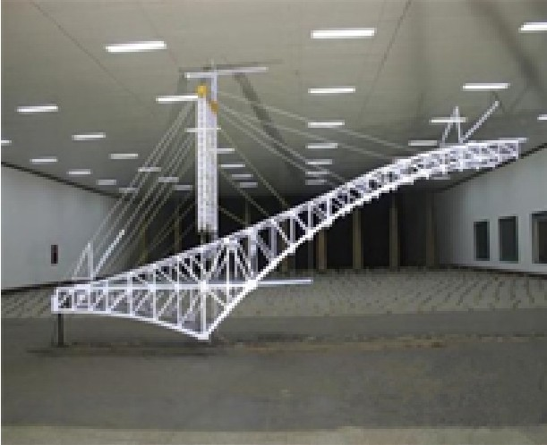
http://windeng.bjtu.edu.cn/index.htm

【会议期间天气情况 /Weather 】

10 月 12 日 / 周三 |  | 10 月 13 日 / 周四 |  | 10 月 14 日 / 周五 |  | 10 月 15 日 / 周六
白天：多云 | 夜间：多云 | 白天：多云 | 夜间：多云 | 白天：多云 | 夜间：多云 | 白天：多云 | 夜间：多云
高温：26℃ 1012hPa 低温：16℃ |  | 高温：27℃ 1015hPa 低温：17℃ |  | 高温：27℃ 1009hPa 低温：19℃ |  | 高温：24℃ 1007hPa 低温：16℃
风向：无持续风向 风力：微风 10％ |  | 风向：无持续风向 风力：微风 59％ |  | 风向：无持续风向 风力：微风 85％ |  | 风向：无持续风向 风力：微风 100％

21

22

23

24

扫描关注《建筑结构》 微信，可以凭手机示 意在会场门口领取精 美小礼品一份！

